CIT419

**Gaming and Simulation Capstone**

***Final Project Report***

**Bass Drop**

***Dillon Wertman***

Fall 2019

*12/2/2019*

**Pennsylvania College of Technology**

TABLE OF CONTENTS

1 VISION STATEMENT 3

1.1 GAME/SIMULATION LOGLINE 3

1.2 GAMEPLAY SYNOPSIS 3

1.3 AUDIENCE AND SYSTEM REQUIREMENTS 3

1.3.1 TARGET AUDIENCE 3

1.3.2 PLATFORM 3

1.3.3 SYSTEM REQUIREMENTS 3

2 CAPSTONE REQUIREMENTS 3

2.1 PROGRAMMING COMPONENT 3

2.2 DATABASE COMPONENT 4

2.3 WEB COMPONENT 4

2.4 INFORMATION ASSURANCE AND SECURITY COMPONENT 4

3 RESEARCH 4

3.1 RESEARCH COMPONENT 4

3.2 RESEARCH SOURCES 4

4 REFLECTIONS 4

# VISION STATEMENT

## GAME/SIMULATION LOGLINE

You are an elite fisherman competing against other tournament fishers in order to become the greatest angler in the world in this fast-paced fishing game.

## GAMEPLAY SYNOPSIS

Gameplay

The player is placed in an open-area garden to explore and search different bodies of water (ponds and lakes) to find fish. Each body of water will hold a random assortment of fish, and each is populated during the game start up. Players can interact with a body of water to cast their lines and attempt to catch fish. Players can play alone or with friends via split screen local multiplayer.

Goal

The goal of Bass Drop is to provide a fun fishing experience, without taking itself too seriously. Fishing is fun, fishing is universal, and fishing can be a social event. Bass Drop will be a model of combining these elements of fishing into a fun game for everyone. Players will be able to explore an open area garden and find the best spots for fishing. Players will be able to view an online leaderboard and push their progress to this leaderboard, allowing players to compete with others across the globe. Socially, the goal is to connect players through this game, and entertainment-wise, the goal is to create a brand-new fishing game that is maybe abstracted from reality by its science fiction and cyberpunk aesthetic, but still provides an enjoyable fishing experience.

Uniqueness

Most fishing games focus on the marketing aspect of pushing products. For a lot of brand-name fishing games, reels, rods, bait, tackle, and other equipment are what matter. There is less a focus on the experience of the game and more emphasis on smaller elements of the game. On the other hand, some fishing games are far too simplistic to be any fun. The prime example of this is Wii Play’s fishing game, which featured 2-dimensional fish in a 3-dimensional world where the player could dip their line into the water, catch a fish, and receive a score based on what type of fish it was. Simple, playable, but after only a short time the game lost its enjoyment because it wasn’t diverse enough to keep its playability. One of my goals for Bass Drop is to move the game away from a blatant marketing scheme but keep it diverse enough to ensure it does not lose its enjoyment after only a few hours of gameplay.

Mechanics

Fishing – Fishing is similar to that of bow fishing or spear fishing. The player has what essentially is a grappling hook that they can fire into the water at a fish. If the hook touches a fish, the fish is reeled in automatically.

Spawning

Spawning will handle where the player spawns in the game world and where the fish spawn in the game world. A spawn area contains an assortment of waypoints that the fish AI uses to move between. If a fish collides with another fish, they pick another waypoint to travel to.

Movement

Players have a lot of control over mobility. If fishing is not great at one spot players can up and move to another. Also, if a player fails to catch a fish they will be put back in free movement. Exploration is also key to finding the best spots to fish. However, exploration is not necessarily discovering new locations but rather moving about the game world until one can see a fish.

Scoring

Scoring will handle how fish will increase their score. The player score at the end of the current game can be pushed to an online database. Players will be able to see other players’ scores via a leaderboard. Different fish are worth a certain number of points based on color:

Orange – 50pts

Red – 100pts

Yellow – 125pts

Blue – 150pts

Green – 400pts

Setting

Bass Drop takes place in the year 2333 in the fictional City of Nobles, a futuristic skyline with bright lights and home to big dreams. The city’s favorite past time is fishing, which is mostly done in Battery Garden, an expansive, largely unlit garden on the east side of the city. Any angler worth his or her salt comes to the garden to practice the craft of fishing.

Look and feel

Aesthetic

Bass Drop incorporates sci-fi cyberpunk elements to create a brand-new fishing experience. From the neon glow of the city skyline to the small lights that adorn cyborg fish, elements of a futuristic setting surround the player.



“City Night.” Deviantart. 2010.

Technical Look and Feel

Bass Drop is in the first person POV with minimal GUI layout. The player’s current score and a time limit is also displayed.

## AUDIENCE AND SYSTEM REQUIREMENTS

## TARGET AUDIENCE

Demographically, any age, gender, and people anywhere in the world will be able to play this game, as fishing is a pretty universal activity. Bass Drop is all about fishing, which isn’t really a limiting activity. Bass Drop will steer clear of explicit sexual themes, drug references, gore, and anything else that would put a Teen or higher rating on this game.

## PLATFORM

Bass Drop is developed for PC only. As a platform, PC is extremely flexible and widespread which puts Bass Drop in the hands of more players.

## SYSTEM REQUIREMENTS

Because Unity will be used to develop this game, the system requirements for developing and running Unity games Unity conveniently lists the minimum system requirements for both developing and running Unity games. The following is a list of these requirements:

- **OS**: Windows 7 SP1+, macOS 10.12+, Ubuntu 16.04+

-Graphics card with DX10 (shader model 4.0) capabilities.

-CPU: SSE2 instruction set support.

# CAPSTONE REQUIREMENTS

## PROGRAMMING COMPONENT

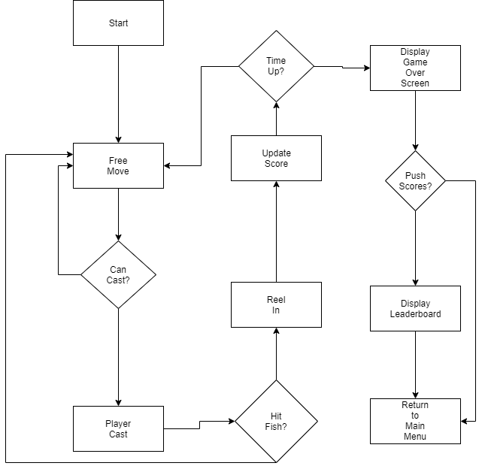

Gameplay Diagram

Above is the gameplay diagram detailing the flow of gameplay for the player. Details described in section 1.2 under “Gameplay.”

Engine and languages

The Unity Game Engine is used to handle creation of game world, models, and physics interactions. C# was the main programming language for all non-database scripts. PHP was used as an interface with the player to access and manipulate database info.

Fish are made up of scriptable objects that contain their name, value, and size. This makes it easier to organize and identify different fish. Player events that describe what happens when a fish is caught, namely passing fish data like size and value, also use scriptable objects for organization and easy identification. These player events communicate with the player’s script to add to score and such.

A spawn manager script is attached to a game object with any number of child objects that are tagged as waypoints. The spawn manager allows the developer to enter in any number of spawnable AI groups, which are in Bass Drop all fish. These groups are further defined by the developer, who can place fish prefabs in the AI group and decide how many should spawn in total and how many spawn at a time. The spawn manager randomly spawns a random amount of AI between 0 and the parameters set by the developer.

Player movement is controlled by a first-person controller script, one accepts input from the keyboard and the other accepts input from a controller, which allows two players to play simultaneously. Players each get a grappling hook looking tool with which they can catch fish. Players are able to move and aim at a fish, fire the hook, and hopefully catch a fish. The hook of the tool extends a distance set by the developer and returns if it hit anything but a fish. Once it hits a fish, it makes the fish a child of itself and translates its position back to the player. Once it is within a developer set distance from the player, it is destroyed and its score is added to the players’. The interaction between the tool and fish is handled by a script attached to the player.

A game manager script keeps track of each players score and a time limit. Each player script keeps track of time and score and displays it in the upper corners of the screen. The game manager also handles input for when a player moves between menu screens.

## DATABASE COMPONENT

A database containing player information is used and hosted online through 000webhost.com. The following information is contained in the database:

-Player login name

-Login password

-Player id

-Player score.

When the game starts, both players are automatically registered and placed in the database. In the end screen players can push their scores to the database and update their scores if the player already exists. Then, a screen is displayed that pulls player info from the leaderboard and display it.

## WEB COMPONENT

The web-based component will be satisfied by an online leaderboard that displays player fishing records. This will enhance the social aspect of Bass Drop as players can use this leaderboard to compete with each other by comparing scores.

## INFORMATION ASSURANCE AND SECURITY COMPONENT

Players shouldn’t be accessing information that’s sensitive

Keeping up with maintenance on server issues and the like will ensure players receive accurate information.

Storing player info server side will keep it out of the hands of people who aren’t allowed to see it.

Security by design is the first priority in making Bass Drop a secure game. Specifically, players never directly access information on the server. PHP scripts are used as an interface to communicate to the server from the game, and players cannot enter any information. Players cannot enter in console commands or access information and data offline either as the only inputs allowed are mapped to movement and catching fish.

# RESEARCH

## RESEARCH COMPONENT

I would like the research mainly to be about the social aspect of the game. Video games offer a new platform in social interaction which is never a waste of time, which some might believe about it. One of the things about fishing is that it is social, so to remove that component would be to take away from the experience of a fishing game. This research is of an observational nature and took place mostly during play testing, however the decision for a multiplayer game was driven solely by a curiosity in the social interaction between players through the medium of video games. Although empirical data was not collected, a qualitative analysis would describe the interactions between players competitive and engaging. Having a winner and loser drove competition and encouraged interaction between players.

## RESEARCH SOURCES

Lenhart, A., Kahne, J., Middaugh, E., Macgill, A., Evans, C., & Vitak, J. (2008). Teens, video games and civics: teens’ gaming experiences are diverse and include significant social interaction and civic engagement. Pew Internet & American Life Project. Retrieved from https://eric.ed.gov/?id=ED525058/

[Creagines]. (2018, Nov 25). Unity easy backend php and mysql for unity. [Video file]. Retrieved from https://www.youtube.com/watch?v=utwSPVGZiiw&list=PLTm4FjoXO7nfn0jB0Ig6UbZU1pUHSLhRU

[The Messy Coder]. (2017 Sep 9). Unity fish AI tutorial. [Video file]. Retrieved from https://www.youtube.com/watch?v=Duy4ZrT8STw&t=685s

# REFLECTIONS

The biggest lesson I learned from this project is how to handle and manage scope. I spent a lot of time working on things that I either lacked the knowledge to implement, or ran out of time to finish. This resulted in a lot of downsizing on scope. For instance, although I had initially wanted a realistic fishing experience with a rod that functioned properly, I couldn’t quite seem to implement that exact vision within my project. But what I implemented, which works more like a grappling hook, actually played into a faster-paced experience, which increased engagement between players. And though I had wanted to implement a more online experience with players playing together across a server, stepping back and solely implementing an offline multiplayer system made for much more instant competition as players interacted with each in real time in shared space.

My passion for gaming is to change society’s views on gaming. That is such a huge proposition and though I struggle with scope, I doubt I could ever bring that to fruition through a single game. Passion can be realized in increments, and I have the entire rest of my life to figure out each and every step. I hope to be just as ambitious with future projects because the worst that can happen is I grow from the experience. I wish I had realized my exact passion sooner, and that could be accomplished through passion discerning exercises earlier in the program. For up and coming students, I would recommend that they visualize their passions and come up with game ideas that allow them to explore pieces of that passion. It has been a great joy to me to complete this project and I learned invaluable information throughout this process.